# Design Principles and Patterns

**Exercise 1: Implementing the Singleton Pattern Scenario:**

**You need to ensure that a logging utility class in your application has only one instance throughout the application lifecycle to ensure consistent logging.**

**PROGRAM:**

public class EagerSingletonLogger { static class Logger {

private static final Logger instance = new Logger(); private Logger() {

System.out.println("Logger instance created.");

}

public static Logger getInstance() { return instance;

}

public void log(String message) { System.out.println("[LOGGER] " + message);

}

}

public static void main(String[] args) { Logger loggerA = Logger.getInstance(); loggerA.log("This is the first message."); Logger loggerB = Logger.getInstance(); loggerB.log("This is the second message."); if (loggerA == loggerB) {

System.out.println("Same Logger instance used. Singleton verified!");

} else {

System.out.println("Different Logger instances. Singleton failed!");

}

}

}

**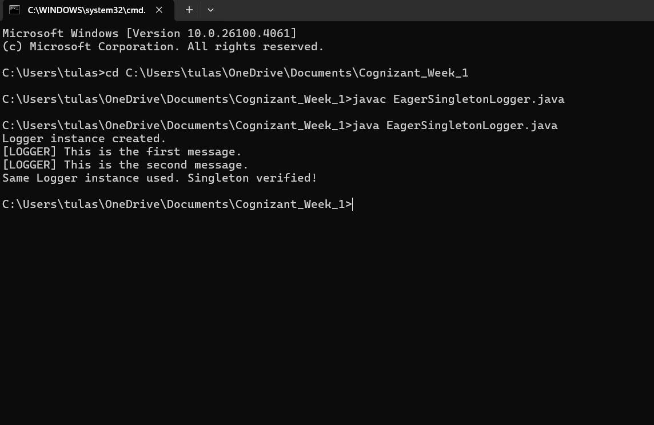OUTPUT:**

**Exercise 2: Implementing the Factory Method Pattern Scenario:**

You are developing a document management system that needs to create different types of documents (e.g., Word, PDF, Excel). Use the Factory Method Pattern to achieve this.

## PROGRAM:

interface Document { void render();

}

class WordDocument implements Document { public void render() {

System.out.println("Opening a Word Document (.docx)...");

}

}

class PdfDocument implements Document { public void render() {

System.out.println("Opening a PDF Document (.pdf)...");

}

}

class ExcelDocument implements Document { public void render() {

System.out.println("Opening an Excel Document (.xlsx)...");

}

}

interface DocumentFactory { Document createDocument();

}

class WordFactory implements DocumentFactory { public Document createDocument() {

return new WordDocument();

}

}

class PdfFactory implements DocumentFactory { public Document createDocument() {

return new PdfDocument();

}

}

class ExcelFactory implements DocumentFactory { public Document createDocument() {

return new ExcelDocument();

}

}

public class Main {

public static void main(String[] args) { DocumentFactory wordFactory = new WordFactory(); Document word = wordFactory.createDocument(); word.render();

DocumentFactory pdfFactory = new PdfFactory();

Document pdf = pdfFactory.createDocument(); pdf.render();

DocumentFactory excelFactory = new ExcelFactory(); Document excel = excelFactory.createDocument(); excel.render();

}

}

**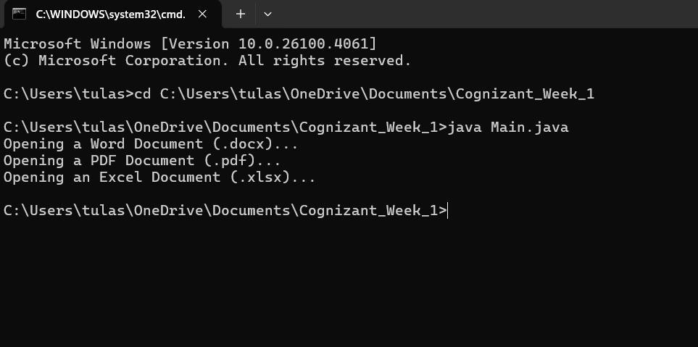OUTPUT:**

# Data Structures and Algorithms

**Exercise 1: E-commerce Platform Search Function Scenario:**

**You are working on the search functionality of an e-commerce platform. The search needs to be optimized for fast performance.**

## PROGRAM:

import java.util.Arrays; import java.util.Comparator;

public class ECommerceSearch { static class Product {

int productId;

String productName; String category;

Product(int productId, String productName, String category) { this.productId = productId;

this.productName = productName; this.category = category;

}

@Override

public String toString() {

return "[" + productId + ", " + productName + ", " + category + "]";

}

}

public static Product linearSearch(Product[] products, String name) { for (Product product : products) {

if (product.productName.equalsIgnoreCase(name)) { return product;

}

}

return null;

}

public static Product binarySearch(Product[] products, String name) { int low = 0, high = products.length - 1;

while (low <= high) {

int mid = (low + high) / 2;

int cmp = products[mid].productName.compareToIgnoreCase(name); if (cmp == 0)

return products[mid]; else if (cmp < 0)

low = mid + 1; else

high = mid - 1;

}

return null;

}

public static void main(String[] args) { Product[] products = {

new Product(101, "Laptop", "Electronics"), new Product(102, "Chair", "Furniture"), new Product(103, "Phone", "Electronics"), new Product(104, "Table", "Furniture"),

new Product(105, "Headphones", "Electronics")

};

System.out.println("Linear Search:");

Product result1 = linearSearch(products, "Phone");

System.out.println(result1 != null ? "Found: " + result1 : "Product not found.");

Arrays.sort(products, Comparator.comparing(p -> p.productName.toLowerCase()));

System.out.println("\nBinary Search:");

Product result2 = binarySearch(products, "Phone");

System.out.println(result2 != null ? "Found: " + result2 : "Product not found.");

}

}

## C:\Users\VIJITHA\AppData\Local\Packages\5319275A.WhatsAppDesktop_cv1g1gvanyjgm\TempState\9CC03CE5C1EA026CA10E9F83572A0200\WhatsApp Image 2025-06-19 at 21.51.08_6bc2cc3d.jpgOUTPUT:

**Exercise 2: Financial Forecasting Scenario:**

**You are developing a financial forecasting tool that predicts future values based on past data.**

## PROGRAM:

public class FinancialForecasting {

public static double forecastRecursive(double currentValue, double growthRate, int years) {

if (years == 0) { return currentValue;

}

return forecastRecursive(currentValue, growthRate, years - 1) \* (1 + growthRate);

}

public static void main(String[] args) { double presentValue = 1000.0; double annualGrowthRate = 0.08; int forecastYears = 5;

double futureValue = forecastRecursive(presentValue, annualGrowthRate, forecastYears);

System.out.printf("Future value after %d years: $%.2f\n", forecastYears, futureValue);

}

}

**OUTPUT**:

